Chapter 1: Introduction to Hands-On AI Screen Navigation

Why Screen Navigation Needs a Practical AI Approach
Modern software systems—especially automotive infotainment systems, mobile applications, and complex HMIs—are no longer static. Screens change dynamically based on context, user profile, vehicle state, language, and software updates. Traditional UI automation techniques rely heavily on fixed object IDs, hard-coded coordinates, or brittle scripts. As a result, even minor UI changes can break large test suites.
AI-based screen navigation addresses this problem by enabling systems to perceive the screen visually and decide actions intelligently, much like a human user. Instead of asking “Is this button present by ID?”, an AI agent asks “What is visible on the screen, and what action should I take next to reach my goal?”
This book focuses on hands-on implementation—not just theory. By the end of this book, you will have built a working AI agent capable of navigating screens using perception models and learned policies.

1.2 What Is AI-Based Screen Navigation?
AI-based screen navigation is the process of enabling an intelligent agent to:
- Observe the current screen (image or video frame)
- Understand UI elements such as buttons, menus, icons, and text
- Decide the next action (tap, swipe, back, wait)
- Execute the action
- Repeat until a goal is achieved
This loop closely resembles how humans interact with screens. The key difference is that an AI agent relies on computer vision, machine learning, and decision-making algorithms instead of predefined scripts.

At a high level, the system consists of:
- A perception module (what is on the screen?)
- A policy or decision module (what should I do next?)
- An execution module (how do I perform the action?)

- 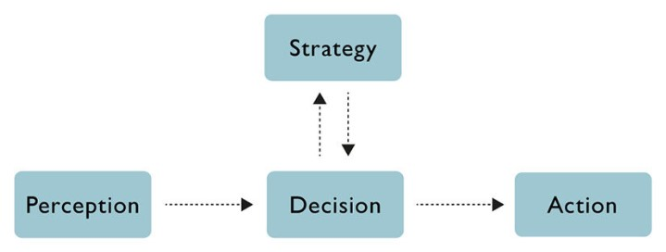

1.3 Where Screen Navigation Is Used
AI-based screen navigation is applicable across multiple domains:
Automotive Infotainment Systems
- Menu navigation testing
- Feature discovery validation
- Variant testing across OEMs and vehicle models
- Regression testing after UI updates
Mobile and Web Applications
- Automated UI testing
- Accessibility validation
- App exploration and crawling
Embedded & Industrial HMIs
- Touch-based control panels
- Safety-critical UI verification
Although examples in this book are generic, automotive infotainment use cases will be emphasized wherever relevant.

1.4 Why This Book Is Different
Most resources on UI automation focus on:
- XPath selectors
- Object repositories
- Fixed coordinate-based interactions
In contrast, this book teaches you how to:
- Treat the screen as an image, not a DOM tree
- Detect UI elements visually
- Encode screen understanding using neural networks
- Learn navigation behavior from human demonstrations
- Adapt to UI changes automatically
The emphasis is always on implementation-first learning. Every major concept will be backed by runnable code and practical exercises.

1.5 System Overview: From Screen to Action
Before diving into code, let us understand the end-to-end workflow that we will implement throughout this book.
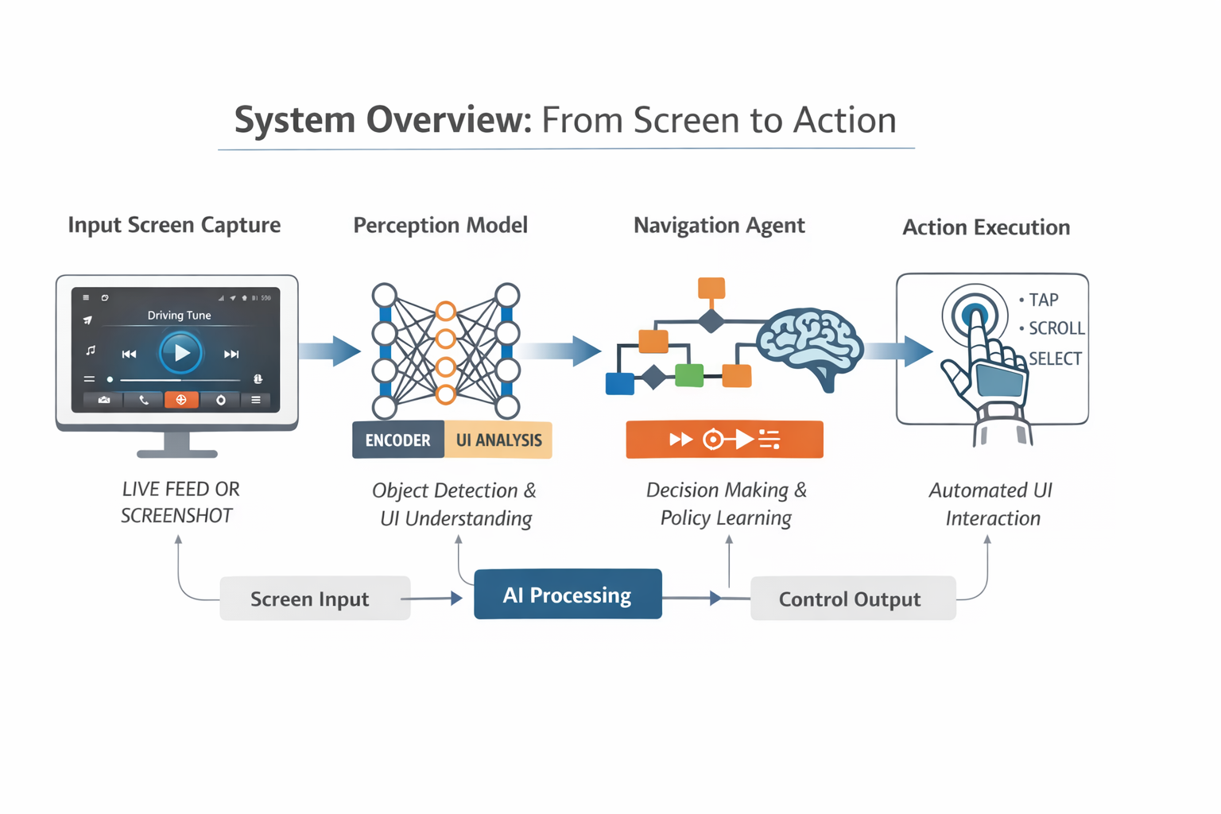
This loop continues until the task is completed or a failure condition is met.

1.6 Tools and Technologies Used in This Book
To keep implementations practical and accessible, this book uses widely adopted tools:
- Python – primary programming language
- OpenCV – image processing
- PyTorch – deep learning models
- YOLO / CNN-based detectors – UI element detection
- Imitation learning frameworks – learning from demonstrations
- Reinforcement learning libraries – policy learning
No prior deep learning expertise is required, but basic Python knowledge is assumed.

1.7 What You Will Build by the End of This Book
By the final chapter, you will have:
- A working screen perception model
- A trained navigation policy
- An end-to-end AI agent that can navigate screens
- A testing framework suitable for infotainment systems
You will also understand how to extend this system to:
- New screen layouts
- Different resolutions
- Multiple UI themes and variants

1.8 How to Use This Book
Each chapter follows a consistent structure:
- Concept overview
- Design decisions
- Implementation walkthrough
- Practical exercises
You are encouraged to run the code, modify parameters, and experiment with your own screens.

1.9 Summary
In this chapter, you learned:
- Why traditional UI automation falls short
- What AI-based screen navigation is
- Where it is used in real systems
- How the end-to-end navigation pipeline works
In the next chapter, we will set up the development environment and create our first screen dataset—laying the foundation for perception-based navigation.

Chapter 2: Environment Setup & Screen Data Capture

2.1 Why Environment Setup Matters
Before building any AI-based screen navigation system, we need a clean and reproducible development environment. Many beginners struggle not because AI concepts are difficult, but because their tools are not set up correctly.
In this chapter, we will:
- Set up a simple Python-based environment
- Install only the essential libraries
- Capture screen images that will act as training data
- Understand what kind of data an AI navigation system needs
You do not need a powerful GPU or advanced hardware to follow this chapter.

2.2 System Requirements (Simple & Practical)
Hardware
- Laptop or desktop (Windows / Linux / macOS)
- Minimum 8 GB RAM (16 GB recommended)
- No GPU required for this chapter
Software
- Python 3.9 or higher
- Internet connection
- Any code editor (VS Code recommended)

2.3 Creating the Python Environment
We will use a virtual environment to avoid conflicts with other projects.
Step 1: Install Python
Check if Python is already installed:
python --version
If not installed, download from: https://www.python.org

Step 2: Create a Virtual Environment
python -m venv screen_nav_env
Activate the environment:
Windows
screen_nav_env\Scripts\activate
Linux / macOS
source screen_nav_env/bin/activate
You should now see the environment name in your terminal.

2.4 Installing Required Libraries
Install the core libraries used throughout this book:
pip install opencv-python numpy pillow matplotlib
Explanation (simple terms):
- OpenCV – reading and processing images
- NumPy – numerical operations
- Pillow – image handling
- Matplotlib – visualization
We will install deep learning libraries later, when needed.

2.5 What Is Screen Data?
Screen data is the visual representation of the user interface.
It usually comes in the form of:
- Screenshots (static images)
- Video frames (sequence of images)
For AI-based screen navigation, screenshots are enough to get started.
Each screen image may contain:
- Buttons
- Icons
- Text labels
- Menus
- Pop-ups
The AI agent learns by looking at these images, not by reading UI code.

2.6 Capturing Screens (Method 1: Manual Screenshots)
This is the simplest and beginner-friendly approach.
Step 1: Create Project Folders
screen_navigation_project/
├── data/
│ ├── raw_screens/
│ └── labeled_screens/
├── scripts/
└── README.md

Step 2: Capture Screens
- Open the application or infotainment simulator
- Navigate through different screens

- Take screenshots using:
  - Print Screen (Windows)
  - Screenshot tool (macOS/Linux)
Save images inside:
data/raw_screens/
📌 Tip: Capture variety
- Different menus
- Different themes
- Different states (enabled/disabled buttons)

2.7 Capturing Screens Programmatically (Python)
For automation, we can capture screens using Python.
Example: Screen Capture Script
from PIL import ImageGrab
import time
import os
output_dir = "data/raw_screens"
os.makedirs(output_dir, exist_ok=True)
for i in range(5):
img = ImageGrab.grab()
img.save(f"{output_dir}/screen_{i}.png")
time.sleep(2)
What this code does:
- Takes a screenshot every 2 seconds
- Saves it as an image file
- Builds a small dataset automatically

2.8 Understanding Screen Annotations (High Level)
To train perception models later, we need annotations.
Annotations describe:
- Where UI elements are located
- What type of element it is (button, icon, text)
At this stage, we only need to understand the concept.
Example annotation (conceptual):
Button: (x=120, y=340, width=200, height=60)
Label: "Settings"
In later chapters, we will:
- Use annotation tools
- Automate part of this process

2.9 Pseudo-Code: Screen Data Pipeline
Below is a high-level pseudo-code for screen data collection:
START
Open application
FOR each screen state:
Capture screen image
Save image to dataset
END
This simple loop forms the foundation of all screen navigation systems.

2.10 Common Beginner Mistakes (Avoid These)
- Capturing too few screens
- Using only one resolution
- Ignoring pop-ups and error states
- Mixing raw and labeled data
Good data quality matters more than complex models.

2.11 Summary
In this chapter, you learned:
- How to set up a clean Python environment
- Which libraries are required
- How to capture screen data manually and programmatically
- How screen data is used in AI-based navigation
You now have the raw material needed to build perception models.

Next Chapter: Building a Basic Perception Model for UI Element Detection

Chapter 3: Building a Basic Perception Model for UI Element Detection

3.1 Why Perception Is the Heart of Screen Navigation
Before an AI agent can decide what action to take, it must first understand what is visible on the screen. This ability to see and interpret the screen is called perception.
Humans instantly recognize buttons, icons, menus, and text. For an AI system, this understanding must be learned using computer vision models.
In this chapter, you will build a simple but powerful perception pipeline that:
- Reads a screen image
- Detects UI elements visually
- Outputs their locations on the screen
This perception model will be reused and improved throughout the rest of the book.
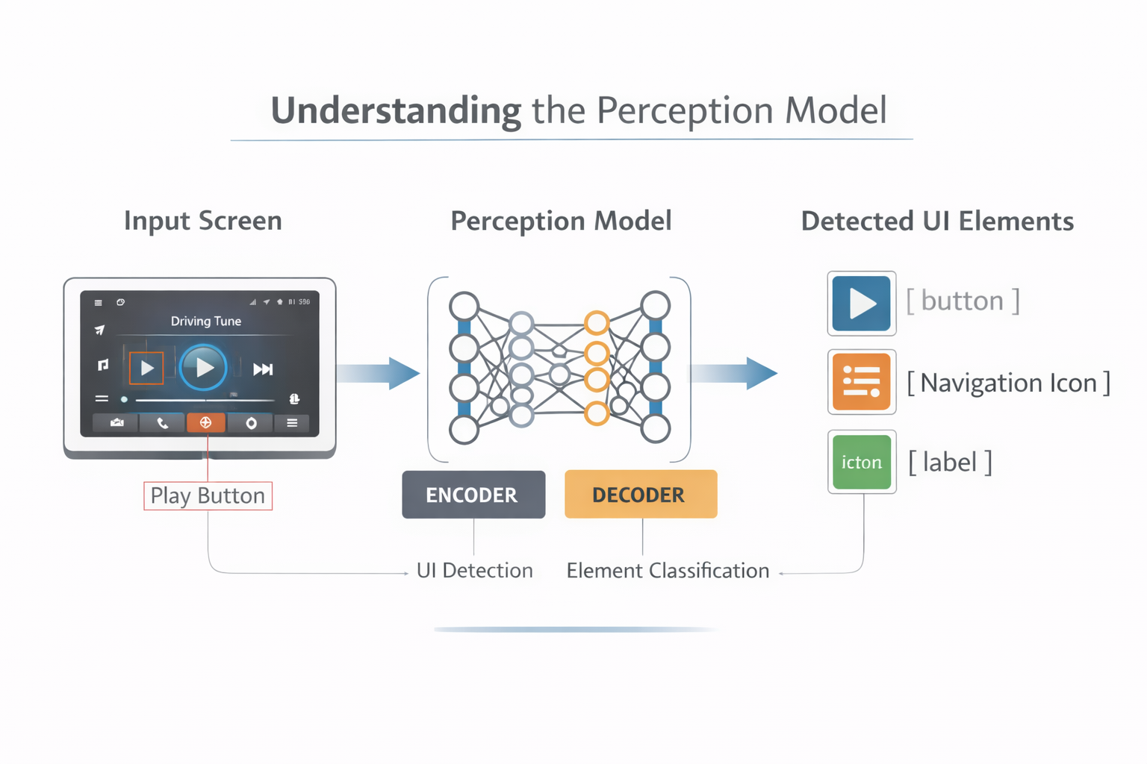

Difference between “Encoder-Decoder” and “Transformer”
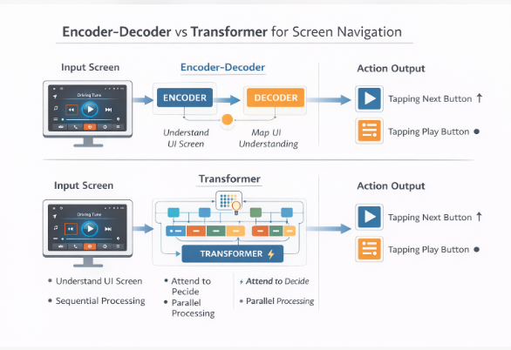

3.2 What Is UI Element Detection?
UI element detection means identifying:
- Where an element is on the screen (location)
- What type of element it is (button, icon, text area)
For example:
- A “Settings” button
- A play/pause icon
- A navigation menu

In this chapter, we focus on bounding-box detection, which is easy to understand and widely used in real systems.

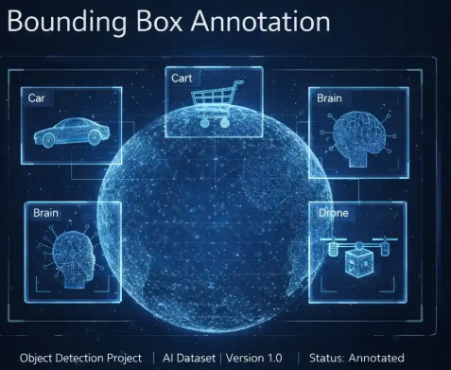

3.3 Simplified Detection Approach (For Beginners)
Instead of jumping directly into complex deep learning models, we start with a practical and incremental approach:
- Load a screen image
- Preprocess the image
- Detect potential UI regions
- Visualize detected elements
This helps you understand the full pipeline before adding learning-based models later.

3.4 Loading and Displaying a Screen Image
Let us start by loading one of the screenshots captured in Chapter 2.
Example Code: Load and Display Image
import cv2
import matplotlib.pyplot as plt
# Load image
image = cv2.imread('data/raw_screens/screen_0.png')
# Convert BGR to RGB
image_rgb = cv2.cvtColor(image, cv2.COLOR_BGR2RGB)
# Display image
plt.imshow(image_rgb)
plt.axis('off')

This confirms that our screen data pipeline is working correctly.

3.5 Image Preprocessing for UI Detection
Raw screenshots often contain noise and unnecessary details. Preprocessing helps simplify detection.
Common preprocessing steps:
- Convert to grayscale
- Blur the image
- Detect edges
Example Code: Preprocessing
# Convert to grayscale
gray = cv2.cvtColor(image, cv2.COLOR_BGR2GRAY)
# Apply Gaussian blur
blur = cv2.GaussianBlur(gray, (5, 5), 0)
# Edge detection
edges = cv2.Canny(blur, 50, 150)
plt.imshow(edges, cmap='gray')
plt.axis('off')

Edges often highlight buttons, panels, and UI boundaries.

3.6 Detecting UI Regions Using Contours
Contours are continuous curves that represent object boundaries.
Example Code: Contour Detection
contours, _ = cv2.findContours(edges, cv2.RETR_EXTERNAL, cv2.CHAIN_APPROX_SIMPLE)
ui_boxes = []
for cnt in contours:
x, y, w, h = cv2.boundingRect(cnt)
if w > 50 and h > 30: # simple size filtering
ui_boxes.append((x, y, w, h))

This step filters out very small shapes and keeps UI-sized regions.

3.7 Visualizing Detected UI Elements
Seeing the results visually is critical for debugging and learning.
Example Code: Draw Bounding Boxes
output = image_rgb.copy()
for (x, y, w, h) in ui_boxes:
cv2.rectangle(output, (x, y), (x+w, y+h), (0, 255, 0), 2)
plt.imshow(output)
plt.axis('off')

You should now see rectangles around potential UI elements.
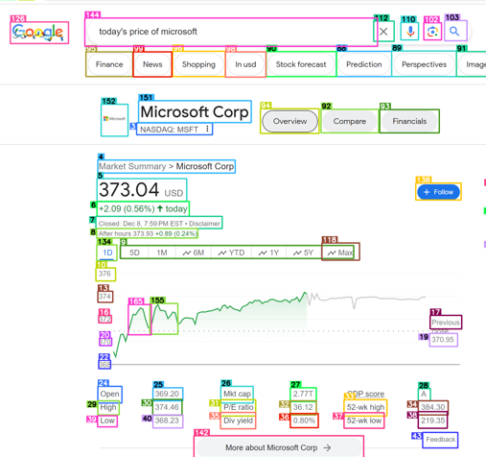

3.8 Why This Simple Model Is Important
Although this approach is not perfect, it teaches key ideas:
- UI detection is visual, not code-based
- Bounding boxes create a structured screen understanding
- Perception output can feed a navigation agent
Later chapters will replace this logic with learning-based detectors like YOLO, but the pipeline remains the same.

3.9 Pseudo-Code: Perception Pipeline
START
Load screen image
Preprocess image
Detect edges
Find contours
Filter UI regions
Return bounding boxes
END
This perception block becomes the eyes of the navigation agent.

3.10 Common Beginner Issues and Fixes
Problem: Too many boxes detected
Fix: Increase minimum width/height filters
Problem: UI elements missed
Fix: Adjust edge detection thresholds
Problem: Slow processing
Fix: Resize image before detection

3.11 Preparing for Learning-Based Models
What we built here is a baseline perception system.
In the next chapter, we will:
- Add labels to UI elements
- Train a learning-based model
- Replace hand-crafted rules with AI
This transition is where screen navigation becomes truly intelligent.

3.12 Summary
In this chapter, you learned:
- What UI element detection means
- How to preprocess screen images
- How to detect UI regions using OpenCV
- How perception feeds navigation systems
You now have a working perception module.

Next Chapter: Creating UI Annotations and Training a Learning-Based Perception Model.

Chapter 4: Installing and Testing Microsoft OmniParser V2 (Hands-On Walkthrough)

4.1 Introduction
In advanced AI screen navigation systems, perception is the foundation. Before an agent can decide where to click or what to type, it must understand what exists on the screen.
In this chapter, we perform a complete hands-on walkthrough of Microsoft OmniParser V2 — a structured screen parsing system that converts raw screenshots into machine-readable UI elements.
This chapter connects directly to our earlier work with OmniTool. While OmniTool focuses on agent behavior and action planning, OmniParser focuses on perception and structured extraction.
Together, they form a powerful perception–action pipeline.
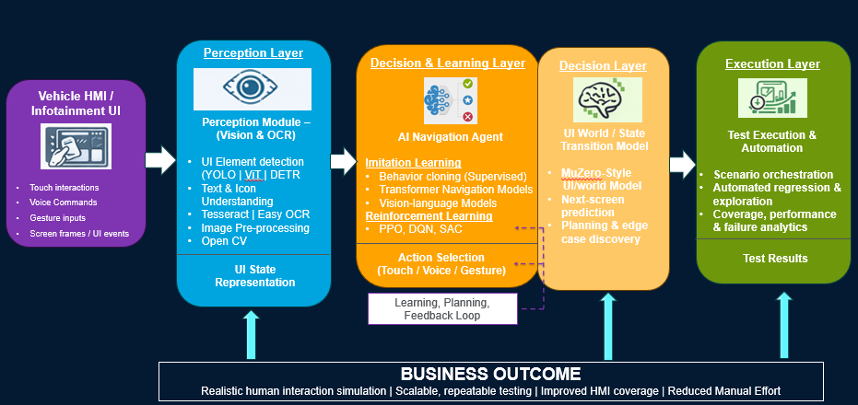

4.2 What OmniParser V2 Does in Screen Navigation
OmniParser V2 transforms:
Raw Screenshot → Structured JSON Output
Instead of only extracting text like traditional OCR, OmniParser attempts to:
- Detect UI components
- Identify text blocks
- Provide bounding box coordinates
- Capture layout hierarchy
- Attach confidence scores
This structured representation allows AI agents to reason about screen elements logically rather than pixel-by-pixel.

4.3 Cloning the OmniParser Repository
Clone the repository from GitHub:
git clone https://github.com/microsoft/OmniParser.git
Navigate into the project folder:
cd OmniParser

4.4 Installing Dependencies
Install required libraries:
pip install -r requirements.txt
Typical dependencies include:
- PyTorch or TensorFlow
- OpenCV
- OCR backends
- Layout analysis libraries
If GPU acceleration is supported:
- Install CUDA
- Install compatible PyTorch GPU version
Always confirm versions mentioned in the repository documentation.

4.5 Running a Basic Parsing Test
Select a test screenshot (for example: dashboard.png).
Run the parser script:
python run.py --input dashboard.png --output result.json
After execution, you should see:
- Terminal logs showing detection progress
- A generated JSON file containing structured results

4.6 Understanding the Output Structure
Open result.json. You will typically observe:
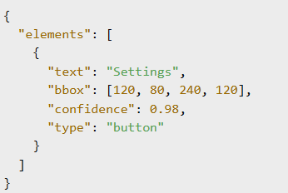
Key Fields Explained:
- text → Extracted visible text
- bbox → Bounding box coordinates (x1, y1, x2, y2)
- confidence → Model confidence score
- type → Predicted UI element type
This structured format enables downstream reasoning.

4.7 Connecting OmniParser with OmniTool
Now we connect perception to action.
Workflow:
- Capture screen
- Send screenshot to OmniParser
- Receive structured JSON
- Pass parsed elements to OmniTool agent
- Agent selects action (click, scroll, type)
This creates a complete AI screen navigation loop:
Perception → Representation → Decision → Action

4.8 Practical Experiment
Try this experiment:
- Take a screenshot of:
  - A web login page
  - A settings dashboard
  - An infotainment screen (if available)
- Run OmniParser
- Observe:
  - Are buttons correctly detected?
  - Are text fields identified?
  - Is layout hierarchy preserved?
- Manually verify bounding box alignment
This validation step is critical before integrating into automation pipelines.
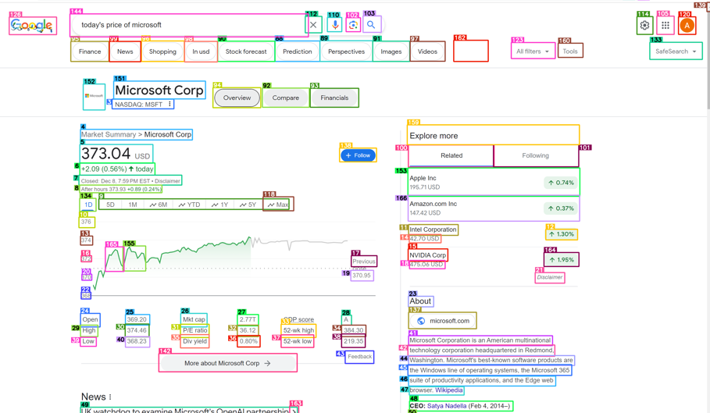

Image that illustrates the bounded boxes across different elements ound on the screen.

4.9 Common Issues and Fixes
Issue: Low text accuracy
Fix: Increase screenshot resolution or improve contrast
Issue: Missing UI grouping
Fix: Adjust layout detection thresholds
Issue: Dependency installation failure
Fix: Verify Python version and GPU compatibility.

